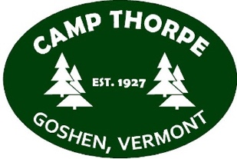
Camp Thorpe Staff Application 2020

Name:
Date:

I will be 18 years of age or older by June, 2020 and would like to apply for one of the following positions:

_____ General Counselor
_____ Arts/Crafts Counselor
_____ Outdoor Recreation Counselor
_____ Lifeguard Counselor (ARC Required)
_____ Music and Movement Counselor
_____ Head Counselor, Pine Haven
____ Head Counselor
_____ Kitchen Staff
_____ Nursing Staff
_____ Registration Nursing Staff
_____ Nature Counselor
_____ Other _____________________________________________________________________________

Describe why you would like to work at a Special Needs Camp.

What type of position are you interested in and why?

What strengths will you bring to this position?

What worries do you have if you should be offered a position.

What experience do you have working with a special needs population?

You will be expected to handle behavioral and personal care issues. Do you feel you will be able to do this?
Yes/No
Comment:

The approximate dates for camp will be June 15th-August 15th. Will you be able to commit to this time? (If not, please explain. Priority will be given to people who can commit fully.)
Camp Thorpe is now a drug-free, smoke-free and alcohol-free campus. This policy has been enacted based on requests from our Insurance Company and Camp America in accordance with J-1 Visa rules, insurance requirements around campers and underage staff, and safety. This includes all activity occurring at camp both during work time and on weekends/days off for all staff members. Are you willing to comply with these rules?
Yes \ No
Please list two references (these should be supervisors, teachers, professors, coaches, or other individuals that have supervised you. Please avoid family members, friends, coworkers, etc)
Reference 1:
Name:
Relationship:
Phone:
Email:
Reference 2:
Name:
Relationship:
Phone:
Email:

Signature of Applicant: Date:

